Facts About Lasers

What is a Laser?
The acronym LASER stands for Light Amplification by Stimulated Emission of Radiation. A laser is a device that produces a beam of monochromatic light in which all the waves are in phase or are coherent.
All lasers contain four primary components:
Active Medium: The active medium may be solid crystals such as Ruby or Nd:YAG, liquid dyes, gases like CO-2 or Helium/Neon, or semiconductors such as GaAs. Active mediums contain atoms whose electrons may be excited to an elevated energy level by an external energy source.
Excitation Mechanism: Excitation mechanisms pump energy into the active medium by one or more of three basic methods; optical, electrical or chemical.
High Reflectance Mirror: A mirror which reflects essentially 100% of the laser light.
Mirror Allowing Partial Transmission: A mirror which reflects less than 100% of the laser light and transmits the remainder.

A simpler definition is that a laser is a device that amplifies light. A laser produces a thin, intense beam of light, which is highly directional (coherent). The light from a laser consists of one, or at the most a few wavelengths (monochromatic), as opposed to light from other sources. Lasers exist, that work in different wavelengths, within the Ultraviolet, Visible as well as Infrared light spectra. Lasers that work with Ultraviolet or Infrared light produce beams that are invisible to the human eye.
Read more Laser Safety Information at Laser Institute of America!
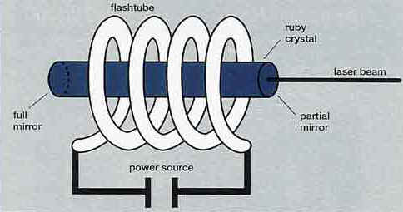
The solid Ruby laser is an example of a pulsed laser. A flash tube emits a burst of light, and the Chromium atoms in the Ruby are excited and raise their energy levels. The stimulated atoms begin oscillation between the mirrors. A laser beam is emitted through the partial mirror.
Lasers produce light beams of varying intensity, and are categorized in accordance with the emitted power. Class 1 represents the weakest laser, and the power gets progressively higher through Class 2, Class 3A, 3B and Class 4.
Class 1
A Class 1 laser is considered safe based upon current medical knowledge. This class includes all lasers or laser systems which cannot emit levels of optical radiation above the exposure limits for the eye under any exposure conditions inherent in the design of the laser product. There may be a more hazardous laser embedded in the enclosure of a Class 1 product, but no harmful radiation can escape the enclosure.
Class 2
A Class 2 laser or laser system must emit a visible laser beam. Because of its brightness, Class 2 laser light will be too dazzling to stare into for extended periods. Momentary viewing is not considered hazardous since the upper radiant power limit on this type of device is less than the MPE (Maximum Permissible Exposure) for momentary exposure of 0.25 second or less. Intentional extended viewing, however, is considered hazardous.
Class 3
A Class 3 laser or laser system can emit any wavelength, but it cannot produce a diffuse (not mirror-like) reflection hazard unless focused or viewed for extended periods at close range. It is also not considered a fire hazard or serious skin hazard. Any continuous wave (CW) laser that is not Class 1 or Class 2 is a Class 3 device if its output power is 0.5 W or less. Since the output beam of such a laser is definitely hazardous for intrabeam viewing, control measures center on eliminating this possibility.
Class 4
A Class 4 laser or laser system is any that exceeds the output limits (Accessible Emission Limits, AEL's) of a Class 3 device. As would be expected, these lasers may be either a fire or skin hazard or a diffuse reflection hazard. Very stringent control measures are required for a Class 4 laser or laser system.
Lasers can also be classified into two categories, continuous lasers and pulsed lasers. Lasers that use gases as a medium generate a continuous beam. Solid lasers use crystal, glass or a semiconductor as the light amplifying substance, and produce a pulsating beam.

